Peter Sanford

IT 2700  
NetLab Lab 25  
12/06/2023

1

Step 3:

Step 9:

Step 14:

2

Step 4:

Step 7:

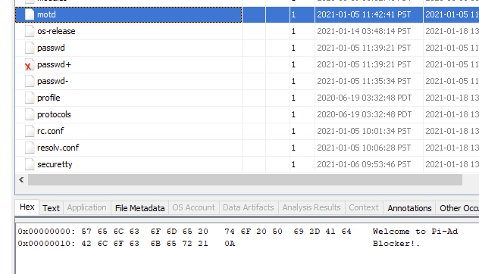

Step 12:

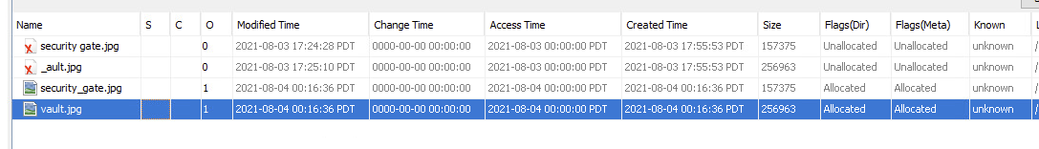

Step 19:

3

Step 5:

Step 6:

Commentary:

In this lab we looked at evidence logging and generating reports. I learned how to tag and comment on files and generate the reports in different formats for each case. Knowing this information, companies can organize their evidence and cases neatly and be able to generate usable reports to send to others.